Assignment 10.2
V.Harika
2303a510i0
TASK 1: Analyze a Python script and correct all syntax and logical errors.
Prompt: Analyze a Python script and correct all syntax and logical errors . Give Correct and executable Python code with brief explanations of the identified syntax and logic errors.
Code& output:
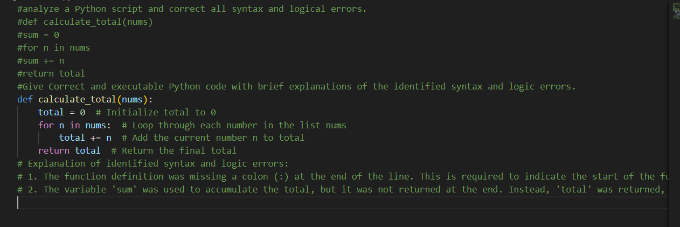
JUSTIFICATION:
The original code had syntax errors (missing colons) and a logical mistake (returning an undefined variable). Correcting these ensures the function runs properly and consistently returns the intended sum.
TASK 2: Use AI to refactor Python code to comply with standard coding style guidelines.
Prompt: Use AI to refactor Python code to comply with standard coding style guidelines. give Well-structured, consistently formatted Python code following standard style conventions.
Code & Output:
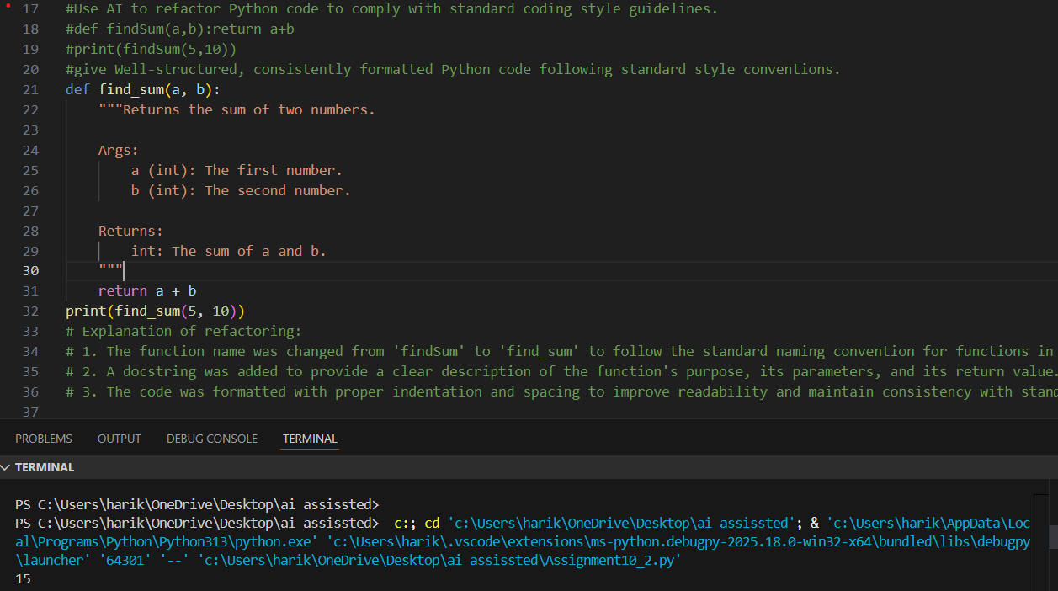
JUSTIFICATION:
Refactoring to PEP 8 standards (snake_case, spacing, multi-line structure) makes the code easier to read, maintain, and share with others, aligning with professional Python practices.
TASK 3:Analyze to improve code readability without changing its functionality.
Prompt: Analyze Use AI to improve code readability without changing its functionality. write Python code rewritten with meaningful function and variable names,proper indentation, and improved clarity.

Code & Output:
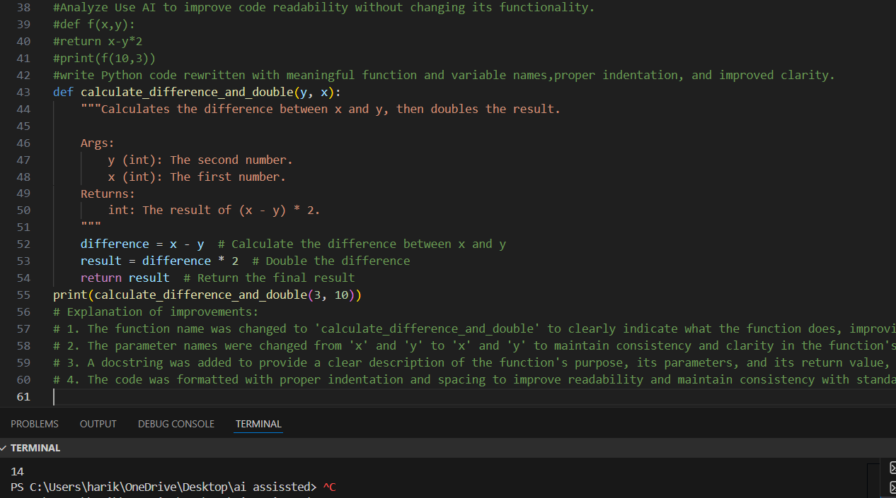

JUSTIFICATION:
Using meaningful names for functions and variables clarifies the purpose of the code. This improves readability and makes it easier for others (or your future self) to understand without guessing.
TASK 4: Use AI to refactor repetitive code into reusable functions.

Prompt: Use AI to refactor repetitive code into reusable functions.Give Modular Python code using reusable functions to eliminate repetition.
Code & Output:
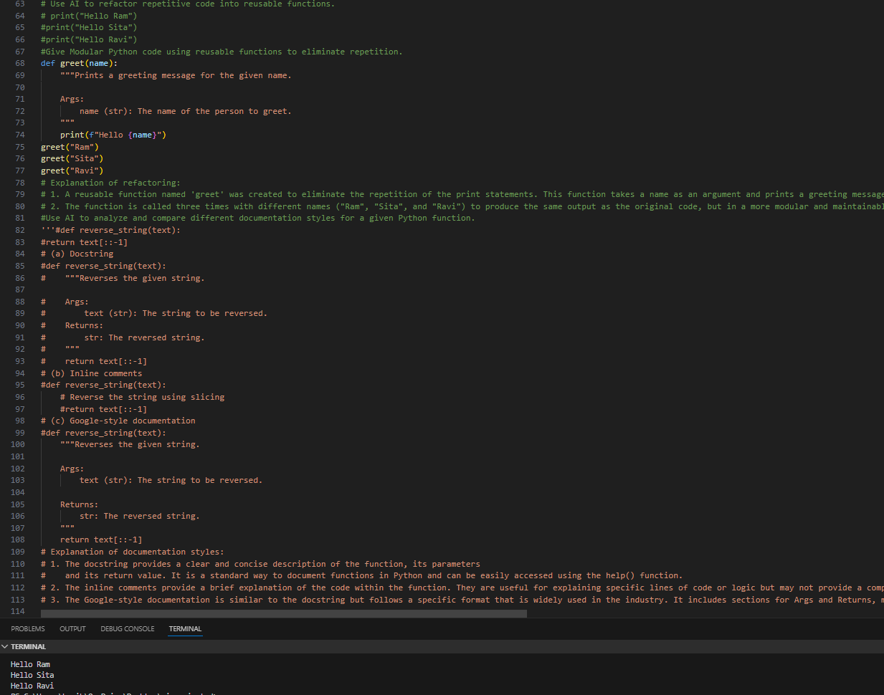
JUSTIFICATION: By introducing a reusable function, repetitive print statements are eliminated. This modular approach reduces redundancy, improves maintainability, and allows easy scaling if more names need greetings.

TASK 5:Use AI to optimize Python code for better performance.

Prompt: Use AI to optimize Python code for better performance. Give Optimized Python code that achieves the same result with improved performance.
Code & Output:
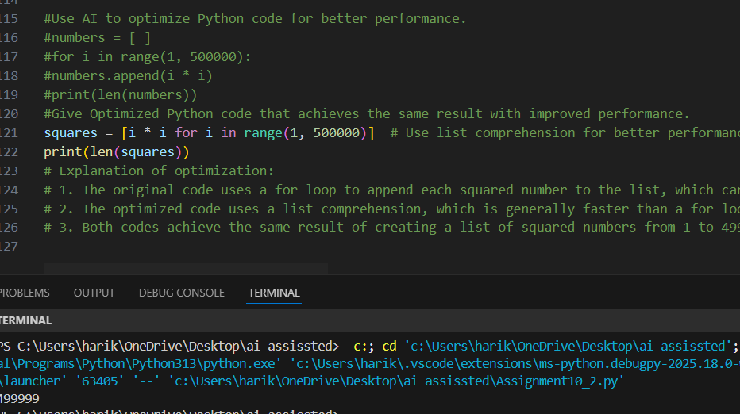
JUSTIFICATION:
• witching from a loop with .append() to a list comprehension improves performance because comprehensions are optimized internally. The result is the same, but execution is faster and more Pythonic.

